Supplementary Material: Title of the corresponding manuscript
[Suggestions: No more than 16 words. Titles are often used in information-retrieval systems. Avoid abbreviations and formulae where possible]

MAIN TEXT (optional)
If necessary, authors may provide a brief description of the supplementary material in this part. We suggest that authors may set headings (level 1 heading, level 2 heading, level 3 heading, etc.) to separate different cases or situations.

How to Use This Template
This template shows the manuscript structure that can be used in supplementary material. Please note that each part has a corresponding style, which authors should follow. Please note that the fonts in gray show writing requirements. For any questions, you may contact the editorial@comengsys.com

Supplementary Table 1. This is a table caption. A summary description of this table should be written here
Tag type | NDEF | Secure messaging | SDM | Random ID | Digital Sig. | Authentication | Memory access protection
NT4H2421Gx  NTAG21x  NTAG210μ | ✔  ✔  ✘ | ✔  ✘  ✘ | ✔  ✘  ✘ | ✔  ✘  ✘ | ✔  ✔  ✔ | ✔  ✘  ✘ | ✔  ✔  ✘
This part is footer. SDM: secure dynamic messaging. This table is cited with permission from XXX et al.^{[1]} published in xxx

Table notes:
- Tables should be cited in numeric order and placed after the paragraph where it is first cited;
- The table caption should be placed above the table and labeled sequentially (e.g., Table 1, Table 2);
- Tables should be provided in editable form like DOC or DOCX format (picture is not allowed);
- Abbreviations and symbols used in table should be explained in footnote;
- Explanatory matter should also be placed in footnotes;
- Non-English words should be avoided;
- Permission for use of copyrighted materials from other sources, including re-published, adapted, modified, or partial tables from the internet, must be obtained. It is authors’ responsibility to acquire the licenses, to follow any citation instruction requested by third-party rights holders, and cover any supplementary charges.
- The font size should not be larger than 12pt and can be adjusted according to the table content.

(1)
Equation note:
- Display equations should be numbered consecutively, using Arabic numbers in parentheses. See Equation (1) for an example;
- Inline equations should not be numbered and should use the same/similar size font as the main text. e.g.
- All equations should be provided in editable form (image file format is not allowed).

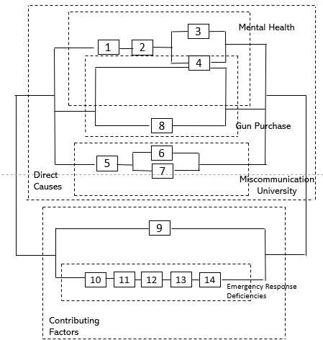  A | 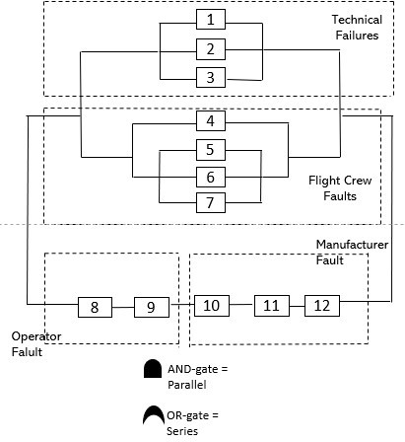  B
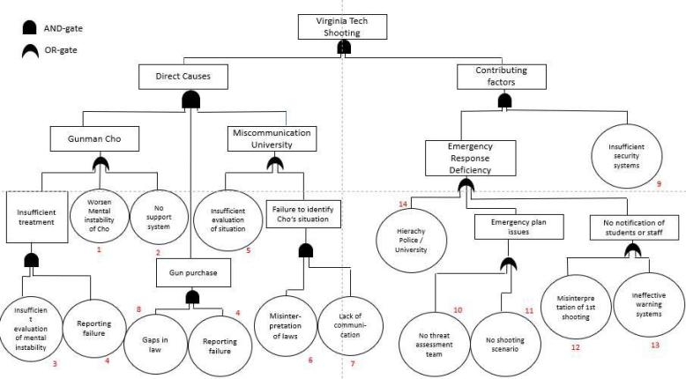
C
Supplementary Figure 1. We present examples of a Reliability Block Diagram of Air XXX airplane crash in Figure 1A-C. A: description of what the Figure 1A is; B: description of what the Figure 1B is; C: description of what the Figure 1C is. This figure is quoted with permission from XX et al.^{[2]}

Figure notes:
- Figures should be cited in numeric order (e.g., Figure 1, Figure 2) and placed after the paragraph where it is first cited;
- Figures can be submitted in format of tiff, psd, AI or jpeg, with resolution of 300-600 dpi;
- Diagrams with describing words (including, flow chart, coordinate diagram, bar chart, line chart, and scatter diagram, etc.) should be editable in word, excel or powerpoint format. Non-English information should be avoided;
- Labels, numbers, letters, arrows, and symbols in figure should be clear, of uniform size, and contrast with the background;
- Symbols, arrows, numbers, or letters used to identify parts of the illustrations must be identified and explained in the legend;
- Internal scale (magnification) should be explained and the staining method in photomicrographs should be identified;
- All non-standard abbreviations should be explained in the legend;
- Authors should pay attention to the protection of patients’ rights, such as privacy and portrait, and obtain signed patient consent from authors before using any personal information of patients. The patient’s portrait with full characters and his/her real name is not allowed for use;
- Permission for use of copyrighted materials from other sources, including re-published, adapted, modified, or partial figures and images from the internet, must be obtained. It is authors’ responsibility to acquire the licenses, to follow any citation instruction requested by third-party rights holders, and cover any supplementary charges.

REFERENCES
Authors should cite references in sequence throughout the manuscript and indicate them in a superscript square bracket with one citation number^{[3]}, two separate citation numbers^{[4,5]} or several consecutive citation numbers^{[6-9]}.
- We suggest that authors should cite appropriate, traceable and latest references be within recent 5 years;
- Each reference should have a corresponding DOI number/website link;
- List all authors when the number of authors is less than or equal to six, if there are more than six authors, only the first three authors’ names should be listed, other authors' names should be omitted and replaced with "et al.";
- The journal’s name should be required to be italicized;
- Journal names should be abbreviated according to the List of Title Word Abbreviations (https://www.issn.org/services/online-services/access-to-the-ltwa/).

Examples of references are shown below:
- Conti M, Dehghantanha A, Franke K, Watson S. Internet of things security and forensics: challenges and opportunities. Future Generation Comp Syst 2018;78:544-6. [DOI: 10.1016/j.future.2017.07.060] [List all authors when the number of authors is less than or equal to six]
- Cao MS, Pan LX, Gao YF, et al. Neural network ensemble-based parameter sensitivity analysis in civil engineering systems. Neural Comput Applic 2017;28:1583-90. [DOI: 10.1007/s00521-015-2132-4] [List the top three authors when the number of authors is greater than six]
- Albasir A, Hu Q, Naik K, Naik N. Unsupervised detection of security threats in cyberphysical system and IoT devices based on power fingerprints and RBM autoencoders. J Surveill Secur Saf 2021; Epub ahead of print [DOI: 10.20517/jsss.2020.19]
- Gaydon AG, Wolfhard HG. Flames. 2nd ed. London: Chapman and Hall Ltd.; 1960. pp. 10-20.
- Mao X, Ding YK. Sentiment feature analysis and harmonic sense evaluation of images. J Electronic 2001;29:23-7. (in Chinese)
- Intel Technology Journal. Developing smart toys - from idea to product. Available from: https://www.intel.com/content/dam/www/public/us/en/documents/research/2001-vol05-iss-4-intel-technology-journal.pdf. [Last accessed on 20 Feb 2021]

See the following website for more types of writing formats: http://www.nlm.nih.gov/bsd/uniform_requirements.html

Standard journal articles (list top three authors)
Author 1 AB, Author 2 CD, Author 3 EF, et al. Title of the article. Abbreviated Journal Name Year; Issue: page range. [DOI: xxxxxx]

Standard journal articles (organization as author)
XXX Research Group. Title of the article. Abbreviated Journal Name Year;Volume:page range. [DOI:xxxx]

Standard journal articles (both personal authors and organization as author)
Author 1 AB, Author 2 CD; XXX Study Group. Title of the article. Abbreviated Journal Name Year;Volume:page range. [DOI: xxxxxx]

Standard journal articles not in English (the title should be translated into English, and clarify the original language in the bracket)
Author 1 AB, Author 2 CD. Title of the article. Abbreviated Journal Name Year; Issue: page range. (in Which language)

Standard journal articles ahead of print (DOI number should be given)
Author 1 AB, Author 2 CD. Title of the article. Abbreviated Journal Name Year; Epub ahead of print [DOI: xxxxxx]

Books
Author 1 A., Author 2 B. Book Title. 3rd ed. Oxford: Publisher; 2008. pp. 154-196.

Chapter in a book
Author 1 A., Author 2 B. Book Title. In: Editor 1 C, Editor 2 D, editors. Title of chapter. New York: Publisher; 2002. pp. 93-113.

Online resource
Title of Site. Title of the article. Available from: URL. [Last accessed on Day Month Year]

Conference proceedings
Editor 1 AB, Editor 2 CD. Title of Presentation. Proceedings of the Name of the Conference; 2001 Sep 13-15; Leeds, UK. New York: Publisher; 2002.

Conference paper
Author 1 A., Author 2 B. Title of the article. In: Editor 1 C, Editor 2 D, editors. Name of the Conference 2002: Proceedings of the Name of the Conference; 2002 Apr 3-5; Kinsdale, Ireland. Berlin: Publisher; 2002. pp. 182-91.

Unpublished material
Author 1 A., Author 2 B. Title of the article. Abbreviated Journal Name Country. Forthcoming Year.

